3. Library Book Reservation System

Aim: To create a cloud-based Library Book Reservation System for SIMATS Library using Zoho Creator to manage book details and availability.
Procedure:
- Log in to Zoho Creator and create a new application.
- Create a form named Library Book Details.
- Add fields such as Book Title, Author, Publication, Year, Edition, Number of Copies, Rack Number, and Status.
- Set the Status options as Taken and Returned.
- Enter book details and save the records
Implementation
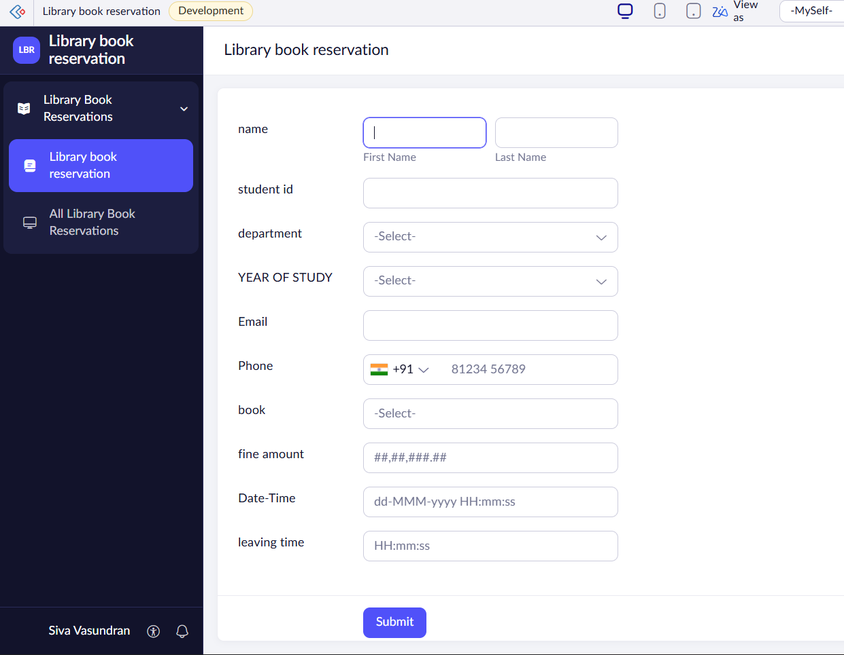
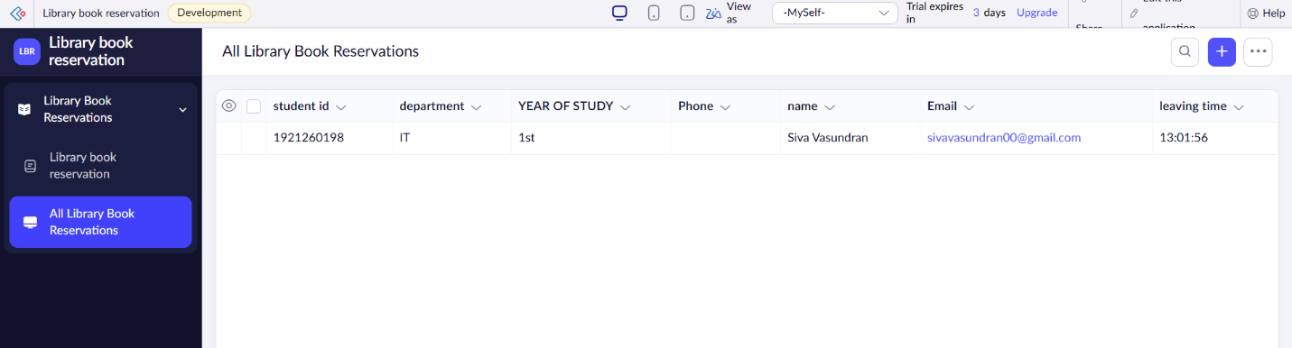

Result: Thus, a cloud-based Library Book Reservation System was created successfully to manage book information and availability.

